Q.create discount calculator for the Book company.

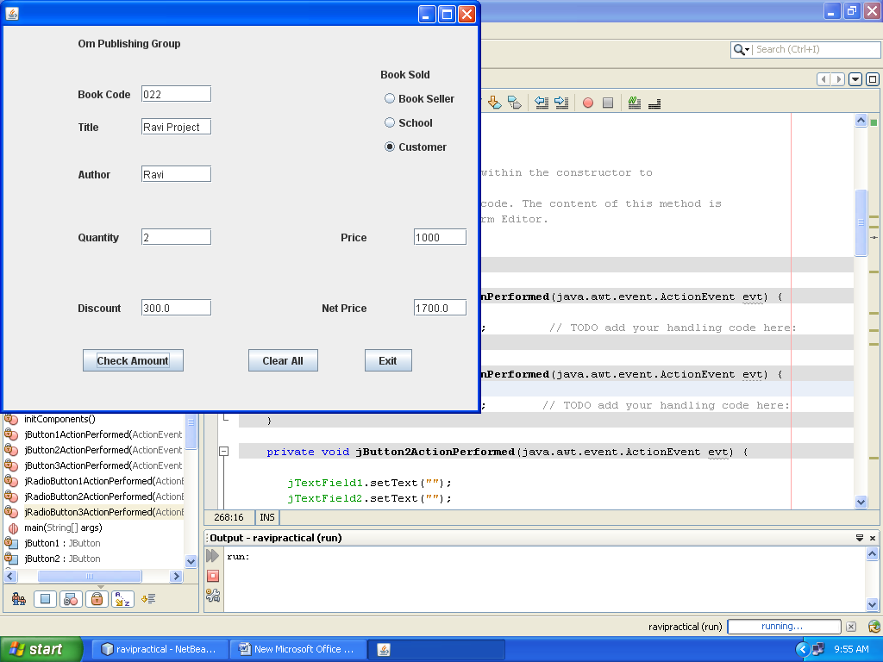

.

|  |  |  |
| --- | --- | --- |
| 1)Write the code for ‘check Amount’ button ?  Ans)  private void jButton1ActionPerformed(java.awt.event.ActionEvent evt) {  int quantity=0,price=0;  double disc=0,netp=0;  quantity=Integer.parseInt(jTextField4.getText());  price=Integer.parseInt(jTextField6.getText());  if (jRadioButton1.isSelected())  {disc=quantity*price*3/10;  }  else if (jRadioButton2.isSelected())  {disc=quantity*price*2/10;  jRadioButton1.setSelected(false);  jRadioButton3.setSelected(false);  }  else if (jRadioButton3.isSelected())  {disc=quantity*price*15/100;  jRadioButton1.setSelected(false);  jRadioButton2.setSelected(false);  }  jTextField5.setText(""+disc);  netp=quantity*price-disc;  jTextField7.setText(""+netp);  }  IP/XI A/RAVI SHANKAR KUMAWAT | **2)Write the code for ‘clear all’ button ?**  **Ans)** private void jButton2ActionPerformed(java.awt.event.ActionEvent evt) {  jTextField1.setText("");  jTextField2.setText("");  jTextField3.setText("");  jTextField4.setText("");  jTextField5.setText("");  jTextField6.setText("");  jTextField7.setText("");  jRadioButton1.setSelected(false);  jRadioButton2.setSelected(false);  jRadioButton3.setSelected(false);  } | **3)Write the code for ‘ Exit’ button show message’Have a Nice Day’?**  **Ans)**  private void jButton3ActionPerformed(java.awt.event.ActionEvent evt) {  JOptionPane.showMessageDialog(null,"Have a nice day");  System.exit(0);  } |

|  |  |
| --- | --- |
| private void jButton2ActionPerformed(java.awt.event.ActionEvent evt) {  jTextField1.setText("");  jTextField2.setText("");  jTextField3.setText("");  jTextField4.setText("");  jTextField5.setText("");  jTextField6.setText("");  jRadioButton1.setSelected(false);  jRadioButton2.setSelected(false);  jRadioButton3.setSelected(false);  }  private void jButton3ActionPerformed(java.awt.event.ActionEvent evt) {  JOptionPane.showMessageDialog(null,"Application Shutdown!");  System.exit(0);  }  private void jRadioButton1ActionPerformed(java.awt.event.ActionEvent evt) {  jRadioButton2.setSelected(false);  jRadioButton3.setSelected(false);  }  jRadioButton1.setSelected(false);  jRadioButton3.setSelected(false);  }  private void jRadioButton3ActionPerformed(java.awt.event.ActionEvent evt) {  jRadioButton2.setSelected(false);  jRadioButton1.setSelected(false);  } | private void jButton1ActionPerformed(java.awt.event.ActionEvent evt) {  int price=Integer.parseInt(jTextField4.getText());  double Finalprice=0;  double discount=0;  if(jRadioButton1.isSelected())  {{if (price<1000)  discount=price*0.30;  jTextField5.setText(""+discount);  if (price>=1000)  discount=price*0.50;  jTextField5.setText(""+discount);}    if (price<1000)  discount=price*0.35;  jTextField5.setText(""+discount);  if (price>=1000)  discount=price*0.55;  jTextField5.setText(""+discount);  }  if(jRadioButton2.isSelected())  { {if (price<1500)  discount=price*0.40;  if (price>=1500)  discount=price*0.50;  jTextField5.setText(""+discount);}    if (price<1500)  discount=price*0.45;  if (price>=1500)  discount=price*0.55;  jTextField5.setText(""+discount);  }  if(jRadioButton3.isSelected())  {{if (price<500)  discount=price*0.20;  jTextField5.setText(""+discount);  if (price>=500)  discount=price*0.30;  jTextField5.setText(""+discount);}    if (price<500)  discount=price*0.25;  jTextField5.setText(""+discount);  if (price>=500)  discount=price*0.35;  jTextField5.setText(""+discount);  }  Finalprice = price-discount;  jTextField6.setText(""+Finalprice);  } |